Exception Handling in Java
The Exception Handling in Java is one of the powerful mechanism to handle the runtime errors so that the normal flow of the application can be maintained.
What is Exception in Java?
In Java, an exception is an event that occurs during the execution of a program that disrupts the normal flow of instructions. These exceptions can occur for various reasons, such as invalid user input, file not found, or division by zero. When an exception occurs, it is typically represented by an object of a subclass of the java.lang.Exception class.
What is Exception Handling?
Exception Handling is a mechanism to handle runtime errors such as ClassNotFoundException, IOException, SQLException, RemoteException, etc.

Java try-catch block
Java try block
Java try block is used to enclose the code that might throw an exception. It must be used within the method.
If an exception occurs at the particular statement in the try block, the rest of the block code will not execute. So, it is recommended not to keep the code in try block that will not throw an exception.
Java try block must be followed by either catch or finally block.
Syntax of Java try-catch
try{
//code that may throw an exception
}catch(Exception_class_Name ref){}
Syntax of try-finally block
try{
//code that may throw an exception
}finally{}
Java catch block
Java catch block is used to handle the Exception by declaring the type of exception within the parameter. The declared exception must be the parent class exception ( i.e., Exception) or the generated exception type. However, the good approach is to declare the generated type of exception.
Fullscreen
The catch block must be used after the try block only. You can use multiple catch block with a single try block.
Internal Working of Java try-catch block
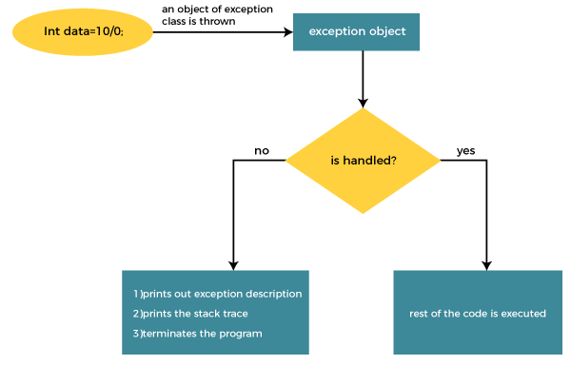
The JVM firstly checks whether the exception is handled or not. If exception is not handled, JVM provides a default exception handler that performs the following tasks:
- Prints out exception description.
- Prints the stack trace (Hierarchy of methods where the exception occurred).
- Causes the program to terminate.
But if the application programmer handles the exception, the normal flow of the application is maintained, i.e., rest of the code is executed.
Problem without exception handling
Let's try to understand the problem if we don't use a try-catch block.
Example 1
TryCatchExample1.java
public class TryCatchExample1 {

public static void main(String[] args) {

int data=50/0; //may throw exception

System.out.println("rest of the code");

}

}
Output:
Exception in thread "main" java.lang.ArithmeticException: / by zero
As displayed in the above example, the rest of the code is not executed (in such case, the rest of the code statement is not printed).
There might be 100 lines of code after the exception. If the exception is not handled, all the code below the exception won't be executed.

Solution by exception handling
Example 2
public class TryCatchExample2 {

public static void main(String[] args) {
try
{
int data=50/0; //may throw exception
}
//handling the exception
catch(ArithmeticException e)
{
System.out.println(e);
}
System.out.println("rest of the code");
}

}
Output:
java.lang.ArithmeticException: / by zero
rest of the code
As displayed in the above example, the rest of the code is executed, i.e., the rest of the code statement is printed.

Here, we handle the exception using the parent class exception.
public class TryCatchExample4 {

public static void main(String[] args) {
try
{
int data=50/0; //may throw exception
}
// handling the exception by using Exception class
catch(Exception e)
{
System.out.println(e);
}
System.out.println("rest of the code");
}

}
Output:
java.lang.ArithmeticException: / by zero
rest of the code

Java Multi-catch block
A try block can be followed by one or more catch blocks. Each catch block must contain a different exception handler. So, if you have to perform different tasks at the occurrence of different exceptions, use java multi-catch block.
Points to remember
- At a time only one exception occurs and at a time only one catch block is executed.
- All catch blocks must be ordered from most specific to most general, i.e. catch for ArithmeticException must come before catch for Exception.
Flowchart of Multi-catch Block
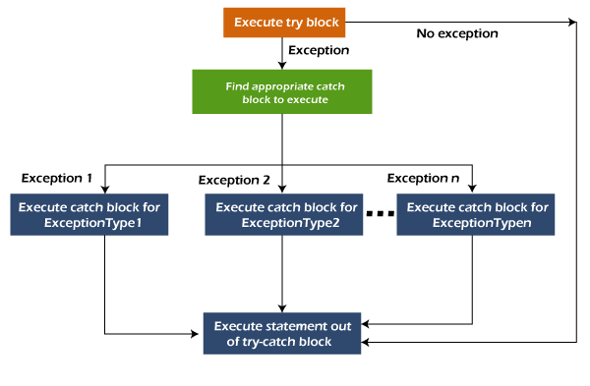
Example 1
Let's see a simple example of java multi-catch block.
MultipleCatchBlock1.java
public class MultipleCatchBlock1 {

public static void main(String[] args) {

try{
int a[]=new int[5];
a[5]=30/0;
}
catch(ArithmeticException e)
{
System.out.println("Arithmetic Exception occurs");
}
catch(ArrayIndexOutOfBoundsException e)
{
System.out.println("ArrayIndexOutOfBounds Exception occurs");
}
catch(Exception e)
{
System.out.println("Parent Exception occurs");
}
System.out.println("rest of the code");
}
}
Output:
Arithmetic Exception occurs

Java finally block
Java finally block is a block used to execute important code such as closing the connection, etc.
Java finally block is always executed whether an exception is handled or not. Therefore, it contains all the necessary statements that need to be printed regardless of the exception occurs or not.
The finally block follows the try-catch block.
Flowchart of finally block
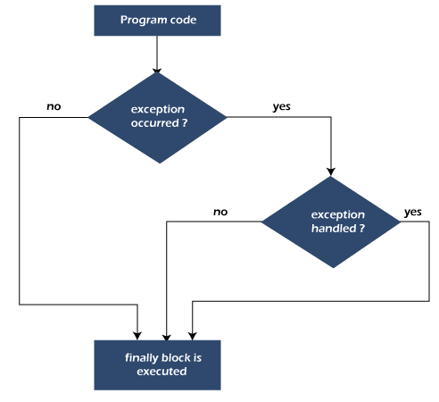
Note: If you don't handle the exception, before terminating the program, JVM executes finally block (if any).
Why use Java finally block?
- finally block in Java can be used to put "cleanup" code such as closing a file, closing connection, etc.
- The important statements to be printed can be placed in the finally block.
Usage of Java finally

Case 1: When an exception does not occur
Let's see the below example where the Java program does not throw any exception, and the finally block is executed after the try block.
TestFinallyBlock.java
class TestFinallyBlock {
public static void main(String args[]){
try{
//below code do not throw any exception
int data=25/5;
System.out.println(data);
}
//catch won't be executed
catch(NullPointerException e){
System.out.println(e);
}
//executed regardless of exception occurred or not
finally {
System.out.println("finally block is always executed");
}

System.out.println("rest of the code...");
}
}

Case 2: When an exception occur but not handled by the catch block
Let's see the following example. Here, the code throws an exception however the catch block cannot handle it. Despite this, the finally block is executed after the try block and then the program terminates abnormally.
TestFinallyBlock1.java
public class TestFinallyBlock1{
public static void main(String args[]){
try {
System.out.println("Inside the try block");
int data=25/0;
System.out.println(data);
}
//cannot handle Arithmetic type exception
//can only accept Null Pointer type exception
catch(NullPointerException e){
System.out.println(e);
}
//executes regardless of exception occured or not
finally {
System.out.println("finally block is always executed");
}

System.out.println("rest of the code...");
}
}
Case 3: When an exception occurs and is handled by the catch block
Example:
Let's see the following example where the Java code throws an exception and the catch block handles the exception. Later the finally block is executed after the try-catch block. Further, the rest of the code is also executed normally.
TestFinallyBlock2.java
public class TestFinallyBlock2{
public static void main(String args[]){
try {
System.out.println("Inside try block");
//below code throws divide by zero exception
int data=25/0;
System.out.println(data);
}
//handles the Arithmetic Exception / Divide by zero exception
catch(ArithmeticException e){
System.out.println("Exception handled");
System.out.println(e);
}

//executes regardless of exception occured or not
finally {
System.out.println("finally block is always executed");
}
System.out.println("rest of the code...");
}
}
Checked exceptions:-
Checked exceptions are the subclass of the Exception class. These types of exceptions need to be handled during the compile time of the program. These exceptions can be handled by the try-catch block or by using throws keyword otherwise the program will give a compilation error.
Unchecked Exception
These types of Exceptions occur during the runtime of the program. These are the exceptions that are not checked at a compiled time by the compiler. In Java exceptions under Error and Runtime Exception classes are unchecked exceptions, This Exception occurs due to bad programming.

Java throw Exception
In Java, exceptions allows us to write good quality codes where the errors are checked at the compile time instead of runtime and we can create custom exceptions making the code recovery and debugging easier.
Java throw keyword
The Java throw keyword is used to throw an exception explicitly.
We specify the exception object which is to be thrown. The Exception has some message with it that provides the error description. These exceptions may be related to user inputs, server, etc.
We can throw either checked or unchecked exceptions in Java by throw keyword. It is mainly used to throw a custom exception. We will discuss custom exceptions later in this section.

public class TestThrow1 {
//function to check if person is eligible to vote or not
public static void validate(int age) {
if(age<18) {
//throw Arithmetic exception if not eligible to vote
throw new ArithmeticException("Person is not eligible to vote");
}
else {
System.out.println("Person is eligible to vote!!");
}
}
//main method
public static void main(String args[]){
//calling the function
validate(13);
System.out.println("rest of the code...");
}
}
Java throws keyword
The Java throws keyword is used to declare an exception. It gives an information to the programmer that there may occur an exception. So, it is better for the programmer to provide the exception handling code so that the normal flow of the program can be maintained.
Exception Handling is mainly used to handle the checked exceptions. If there occurs any unchecked exception such as NullPointerException, it is programmers' fault that he is not checking the code before it being used.
Syntax of Java throws
- return_type method_name() throws exception_class_name{
- //method code
- }
Advantage of Java throws keyword

Fullscreen
It provides information to the caller of the method about the exception.
Java throws Example
Let's see the example of Java throws clause which describes that checked exceptions can be propagated by throws keyword.
Testthrows1.java
import java.io.IOException;
class Testthrows1{
void m()throws IOException{
throw new IOException("device error");//checked exception
}
void n()throws IOException{
m();
}
void p(){
try{
n();
}catch(Exception e){System.out.println("exception handled");}
}
public static void main(String args[]){
Testthrows1 obj=new Testthrows1();
obj.p();
System.out.println("normal flow...");
}
}

Difference Between throw and throws in Java
The throw and throws is the concept of exception handling where the throw keyword throw the exception explicitly from a method or a block of code whereas the throws keyword is used in signature of the method.
There are many differences between throw and throws keywords. A list of differences between throw and throws are given below:
Sr. no. | Basis of Differences | throw | throws
1. | Definition | Java throw keyword is used throw an exception explicitly in the code, inside the function or the block of code. | Java throws keyword is used in the method signature to declare an exception which might be thrown by the function while the execution of the code.
2. | Uses | Type of exception Using throw keyword, we can only propagate unchecked exception i.e., the checked exception cannot be propagated using throw only. | Using throws keyword, we can declare both checked and unchecked exceptions. However, the throws keyword can be used to propagate checked exceptions only.
3. | Syntax | The throw keyword is followed by an instance of Exception to be thrown. | The throws keyword is followed by class names of Exceptions to be thrown.
4. | Declaration | The keyword throw is used within the method. | The keyword throws is used with the method signature.
5. | Internal Implementation | We are allowed to throw only one exception at a time i.e. we cannot throw multiple exceptions. | We can declare multiple exceptions using throws keyword that can be thrown by the method. For example, main() throws IOException, SQLException.
Java throw Keyword
The "throw" keyword in Java is used to explicitly throw an exception. It disrupts the normal flow of the program by transferring control to the nearest catch block that can handle the thrown exception. When an exception occurs within a method, the method creates an exception object and throws it using the "throw" keyword.
Java throw Example
public class TestThrow {
//defining a method
public static void checkNum(int num) {
if (num < 1) {
throw new ArithmeticException("\nNumber is negative, cannot calculate square");
}
else {
System.out.println("Square of " + num + " is " + (num*num));
}
}
//main method
public static void main(String[] args) {
TestThrow obj = new TestThrow();
obj.checkNum(-3);
System.out.println("Rest of the code..");
}
}

Java throws Example
TestThrows.java
public class TestThrows {
//defining a method
public static int divideNum(int m, int n) throws ArithmeticException {
int div = m / n;
return div;
}
//main method
public static void main(String[] args) {
TestThrows obj = new TestThrows();
try {
System.out.println(obj.divideNum(45, 0));
}
catch (ArithmeticException e){
System.out.println("\nNumber cannot be divided by 0");
}

System.out.println("Rest of the code..");
}
}

TestThrowAndThrows.java
public class TestThrowAndThrows
{
// defining a user-defined method
// which throws ArithmeticException
static void method() throws ArithmeticException
{
System.out.println("Inside the method()");
throw new ArithmeticException("throwing ArithmeticException");
}
//main method
public static void main(String args[])
{
try
{
method();
}
catch(ArithmeticException e)
{
System.out.println("caught in main() method");
}
}
}

